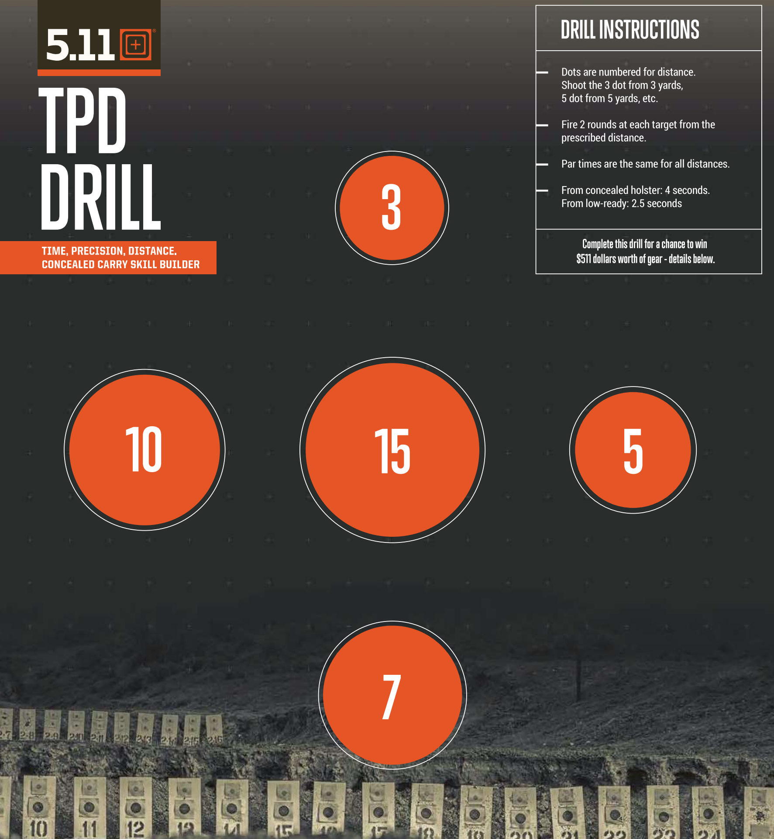p
Defensive Target 3 (all calibers)
Name: ___________________
Time:
3 _______ 10________
5_______ 15________
7________
Date: __________________
Par time: 3 seconds

